

**SUMMER**

**REGISTRATION**

**FORM**

___________________________

FAMILY PASSWORD

**CHILD INFORMATION**: (Please Print)

____________________________________­­­______ _________ ____/_____ /____ ____________

Child’s Last Name First Name Sex Date of Birth Grade

Entering in Fall

____________________________________­­­______ _________ ____/_____ /____ ____________

Child’s Last Name First Name Sex Date of Birth Grade

Entering in Fall

____________________________________­­­______ _________ ____/_____ /____ ____________

Child’s Last Name First Name Sex Date of Birth Grade

Entering in Fall

**PARENT/GUARDIAN INFORMATION**: Email address: ___________________________________

CHILD LIVES WITH □ Both Parents □ Mother □ Father □ Other __________________________

MOTHER’S INFORMATION FATHER’S INFORMATION

NAME: ___________________________________ NAME: _____________________________________

CELL PHONE #: ____________________________ CELL PHONE #: ______________________________

HOME PHONE #: ___________________________ HOME PHONE #: _____________________________

MOTHERS ADDRESS:________________________ FATHER’S ADDRESS: __________________________

_________________________________________ ___________________________________________

Mother Permitted to pick up child? □ Yes □ No Father Permitted to pick up child? □ Yes □ No

**Emergency Contacts:**

Other persons authorized by the parent to pick up my child. If the parent cannot be reached, the following persons may be contacted in case of illness, injury, or emergency. It is the registering parent’s responsibility to keep this list current.

Name Cell Phone # Home Phone # Relationship to the child

1. _________________________ ___________________ ____________________ ________________________

2. _________________________ ___________________ ____________________ ________________________

3. _________________________ ___________________ ____________________ ________________________

4. _________________________ ___________________ ____________________ ________________________

Registering Parent’s SIGNATURE: _______________________________________________________________________

Registering Parent’s PRINTED NAME: ____________________________________________________________________

**Discipline Policy**

THE CHILDREN ARE OUR FIRST PRIORITY

We believe that the children learn from us. We are their role models/ Children are forming habits, attitudes and patterns that will affect them throughout life.

We expect all employees to treat the children in a respectful manner and for the children in turn to respond in the same way. We also expect the children to show this same respect to each other and to use all equipment and facilities in an appropriate manner.

Children who are demonstrating inappropriate behavior will be redirected as a first intervention. For more serious infractions such as biting, fighting, improper language or for repeated infractions, the child will be contacted for assistance. Chronic misbehavior can result in dismissal from the program.

I have read and fully understand the company’s discipline policy.

Parent’s Signature: ___________________________________________________

Date: ___________________________________

**Media Release**

AUTHORIZATION FOR MEDIA RELEASE: I understand Camp eXample, may use photographs and/or digital videos for use in local publications, advertisings, or any other related promotional medium. I waive the right to inspect or approve any photographs or digital video images before they are published and any use to which they may be put.

I Have read the above and hereby give my consent.

Parent’s Signature: ___________________________________________________

Date: _____________________________________

**Consent Form**

I hereby give my consent to have my child participate in all activities at Camp eXample and all food programs including all meals. I give my permission to have my child taken to and from the church on various field trips.

In case of any emergency, Camp eXample will not be responsible for any minor injuries that might occur during the normal camp day (ex. Scratched knee, cuts, bruises, bites, etc.)

In case of any emergency Camp eXample will attempt to reach either parent or the parent or the Emergency Number given by the parent. If for any reason none of these parties are available, I authorize Camp eXamplel to use and transport to, the closest medical facility and grant permission to perform any emergency procedure at the discretion of that medical facility.

I have read the above and hereby give my consent.

Child/ren’s Name: ________________________________________________________________________________

Address: ________________________________________________________________________________________

Parent’s Signature: ___________________________________________

**Authorization of Medication**

NO MEDICATION SHALL BE GIVEN BY CHILD CARE PERSONNEL, WITHOUT THE SIGNED PERMISSION OF A PARENT OF GUARDIAN PLEASE COMPLETE THIS FORM.

Child/ren’s Name: _________________________________________________________________________

Name of Medication or Prescription Number: _____________**SUNSCREEN AND BUG SPRAY**_______________

Time of Medication is to be given: ____________________________**APPLY AS NEED**_____________________

Parents Signature: ___________________________________________________________

Date: __________________

**What We Need To Know About Your Child**

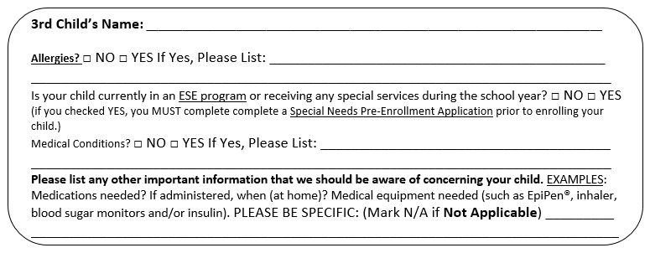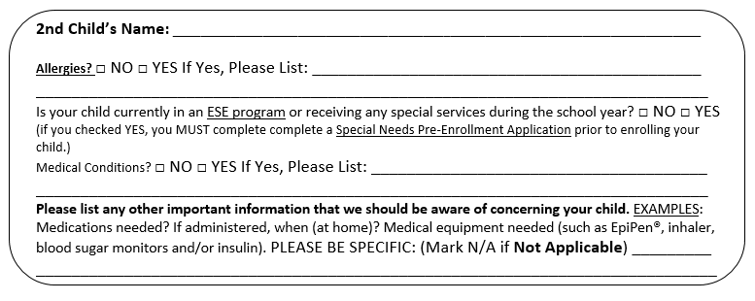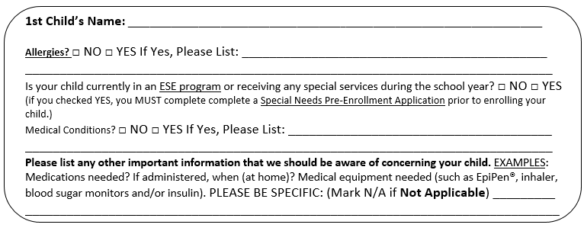PLEASE FILL OUT FOR EACH CHILD